JSON
JSON stands for JavaScript Object Notation it is a:
- is a text format for storing and transporting data.
- is a lightweight data-interchange format
- is plain text written in JavaScript object notation
- is used to send data between computers
- is language independent *
- is “self-describing” and easy to understand.
This example is a JSON string:
‘{“name”:”John”, “age”:30, “car”:null}’
It defines an object with 3 properties:
- name
- age
- car
Each property has a value. If you parse the JSON string with a JavaScript program, you can access the data as an object:
let personName = obj.name;
let ooleane = obj.age;
The JSON format is syntactically similar to the code for creating JavaScript objects. Because of this, a JavaScript program can easily convert JSON data into JavaScript objects.
Since the format is text only, JSON data can easily be sent between computers, and used by any programming language.
JavaScript has a built-in function for converting JSON strings into JavaScript objects:
JSON.parse()
JavaScript also has a built-in function for converting an object into a JSON string:
JSON.stringify()
JSON, values must be one of the following data types:
- a string
- a number
- an object
- an array
- a oolean
- null

You can access a JavaScript object like this:
person.name;
or with
person[“name”];
JSON Example:
{“employees”:[
{ “firstName”:”John”, “lastName”:”Doe” },
{ “firstName”:”Anna”, “lastName”:”Smith” },
{ “firstName”:”Peter”, “lastName”:”Jones” }
]}
The main use of JSON is to exchange data to/from a web server. When receiving data from a web server, the data is always a string. Parse the data with JSON.parse(), and the data becomes a JavaScript object.
‘{“name”:”John”, “age”:30, “city”:”New York”}’
Use the JavaScript function JSON.parse() to convert text into a JavaScript object:
const obj = JSON.parse(‘{“name”:”John”, “age”:30, “city”:”New York”}’);
Then you can use it in your page as a JavaScript object like so:
<p id=”demo”></p>
<script>
document.getElementById(“demo”).innerHTML = obj.name;
</script>

JSON Exercises:
- Decide upon an object for your website like for example (employees, cars, addresses etc.)
- Define an array of at least 4 objects for your array.
- Parse the JSON into a JavaScript object.
- Echo the JavaScript object to your page.

JQuery
jQuery is a JavaScript library that helps simplify some JavaScript programming.
jQuery Hide and Show

With jQuery, you can hide and show HTML elements with the hide() and show() methods:
$(“#hide”).click(function(){
$(“p”).hide();
});

$(“#show”).click(function(){
$(“p”).show();
});

jQuery Sliding
With jQuery you can create sliding effects on HTML elements:
- slideDown()
- slideUp()
- slideToggle()

Example:
$(“#flip”).click(function(){
$(“#panel”).slideDown();
});

jQuery Animation
Example:
$(“button”).click(function(){
$(“div”).animate({
left: ‘250px’,
height: ‘+=150px’,
width: ‘+=150px’
});
});

jQuery Manipulating CSS

Example:
$(“button”).click(function(){
$(“h1, h2, p”).toggleClass(“blue”);
});

JQuery Exerices:
- Use jQuery to hide and show elements of a webpage.
- Use jQuery to create a sliding effect on HTML elements.
- Use jQuery to animate an element.
- Use jQuery to manipulate CSS.

Google Integration
Google Maps API

This example creates a Google Map in HTML:
<!DOCTYPE html>
<html>
<body>
<h1>My First Google Map</h1>
<div id="googleMap" style="width:100%;height:400px;"></div>
<script>
function myMap() {
var mapProp= {
center:new google.maps.LatLng(51.508742,-0.120850),
zoom:5,
};
var map = new google.maps.Map(document.getElementById("googleMap"),mapProp);
}
</script>
<script src="https://maps.googleapis.com/maps/api/js?key=YOUR_KEY&callback=myMap"></script>
</body>
</html>
Google API Tutorial (w3schools.com)

Exercise:
- Add a google maps integration to a webpage.

Create Google Analytics Page
Example/Exercise: Add the Google Analytics script in each .html page and view the page views
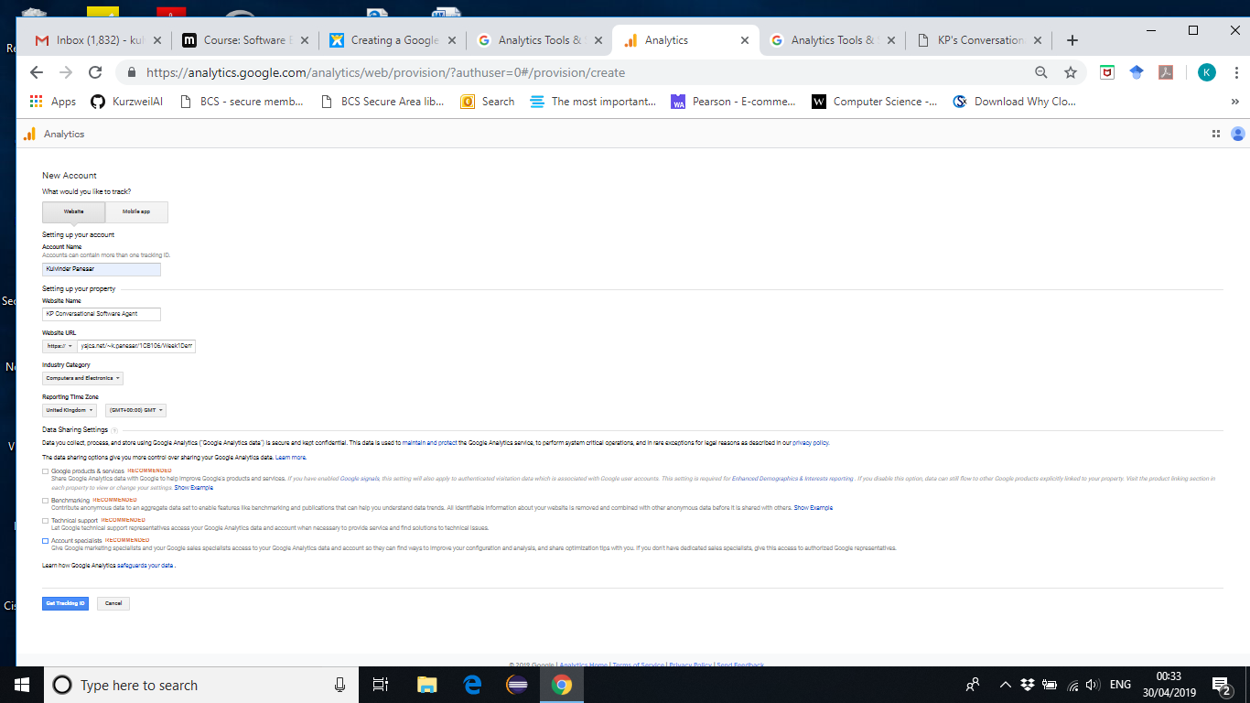
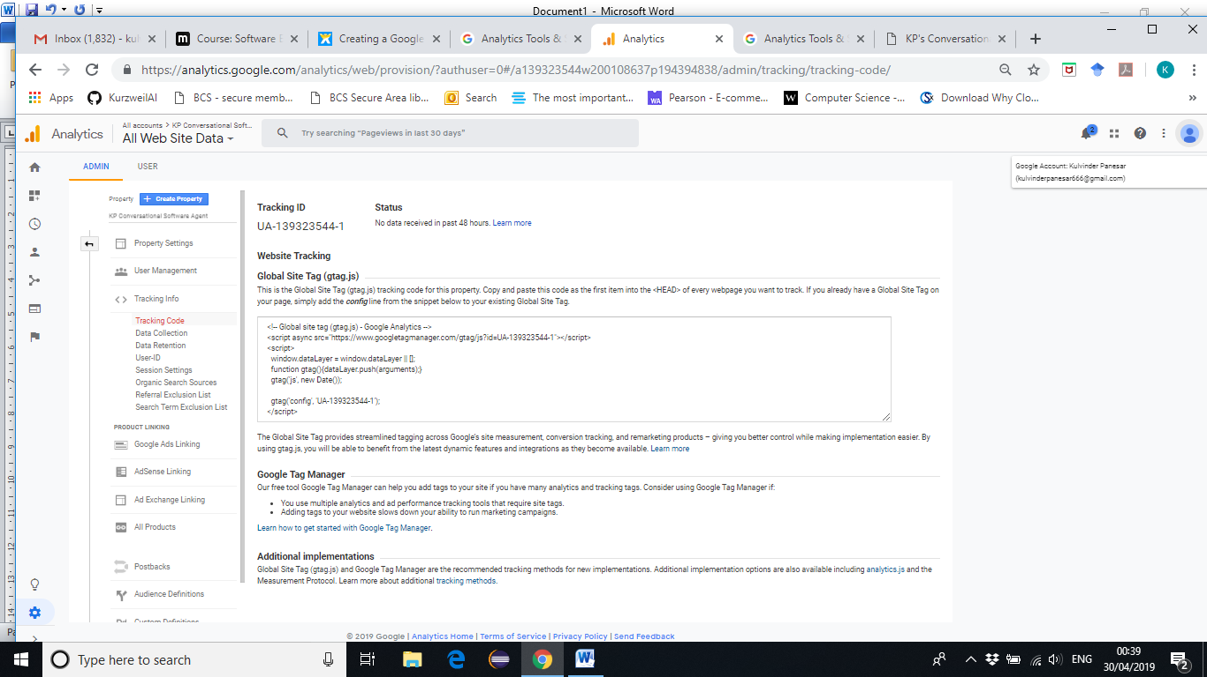

Website Tracking

Global Site Tag (gtag.js)
This is the Global Site Tag (gtag.js) tracking code for this property. Copy and paste this code as the first item into the <HEAD> of every webpage you want to track. If you already have a Global Site Tag on your page, simply add the config line from the snippet below to your existing Global Site Tag.

Link to Google Analytics
https://analytics.google.com/analytics/web/provision/?authuser=0&_ga=2.179143521.474072084.1556581063-355220976.1556581063#/provision
<!-- Global site tag (gtag.js) - Google Analytics -->
<script async src="https://www.googletagmanager.com/gtag/js?id=UA-139323544-1"></script>
<script>
window.dataLayer = window.dataLayer || [];
function gtag(){dataLayer.push(arguments);}
gtag('js', new Date());

gtag('config', 'UA-139323544-1');
</script>

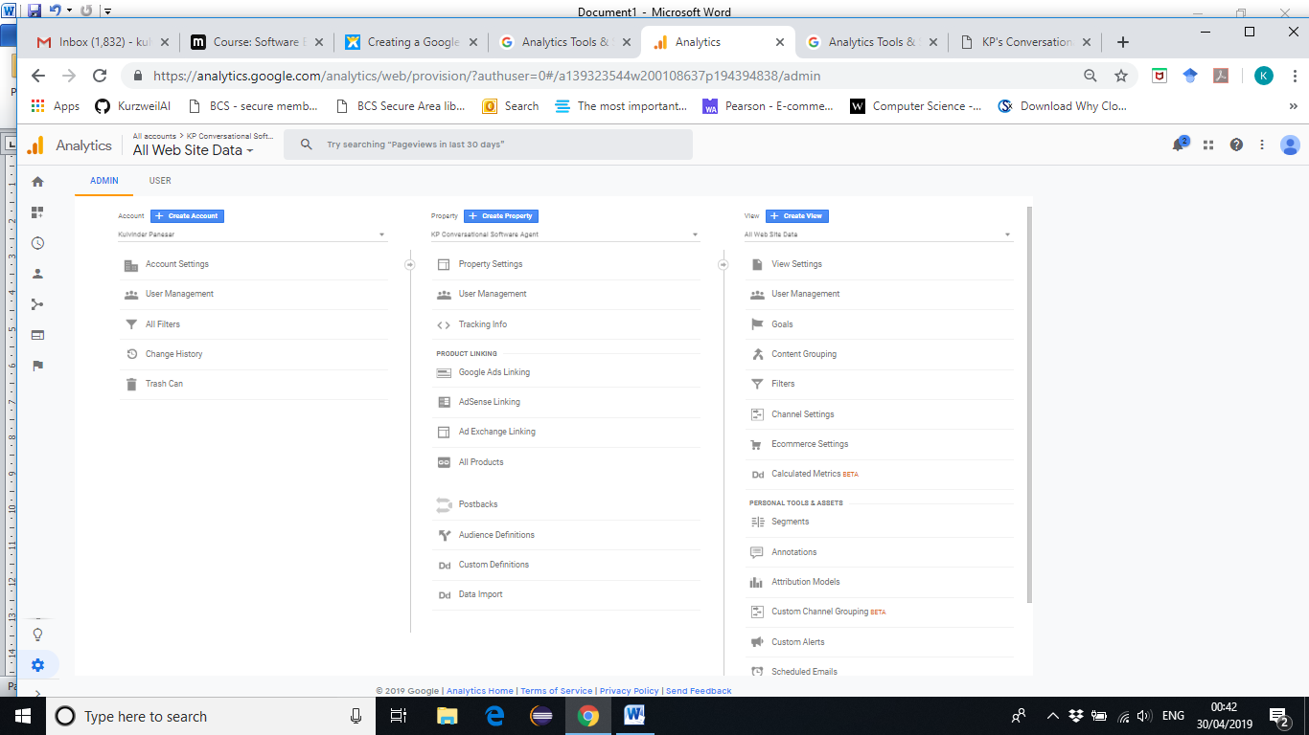

File: index.html
<! DOCTYPE html>

<html>

<head>
<title>KP's Conversational Interfaces is Coming Soon!</title>
<!-- Global site tag (gtag.js) - Google Analytics -->
<script async src="https://www.googletagmanager.com/gtag/js?id=UA-139323544-1"></script>
<script>
window.dataLayer = window.dataLayer || [];
function gtag(){dataLayer.push(arguments);}
gtag('js', new Date());

gtag('config', 'UA-139323544-1');
</script>

</head>
<body>
……..

https://ysjcs.net/~k.panesar/1CB106/Week1DemoHTML/
Open this in different tabs – see the result
